EXP 15
Aim
To perform transformation using the Direct Linear Transformation (DLT) method.
Procedure
- Import OpenCV and NumPy.
- Read the image.
- Define source and destination points.
- Compute the transformation matrix.
- Display the transformed image.
Code
import cv2
import numpy as np
img = cv2.imread("image1.png")
pts1 = np.float32([[0,0],[300,0],[0,300],[300,300]])
pts2 = np.float32([[20,20],[280,30],[40,280],[260,290]])
M = cv2.getPerspectiveTransform(pts1, pts2)
result = cv2.warpPerspective(img, M, (img.shape[1], img.shape[0]))
cv2.imshow("Original", img)
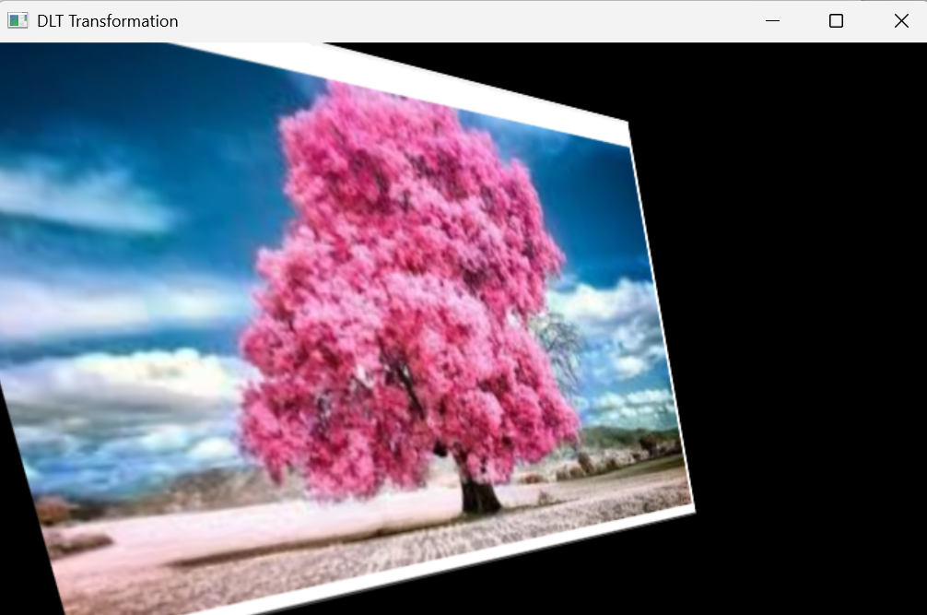
cv2.imshow("DLT Transformation", result)
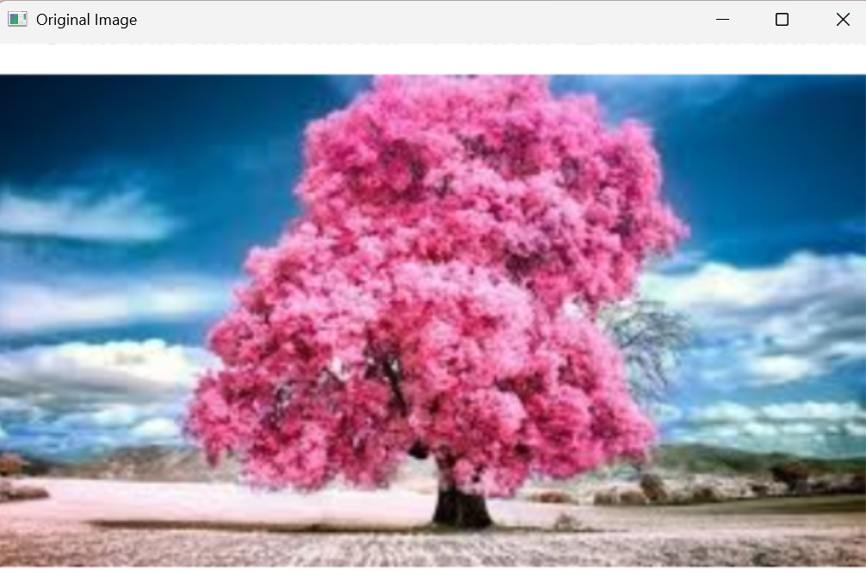
cv2.waitKey(0)
cv2.destroyAllWindows()

